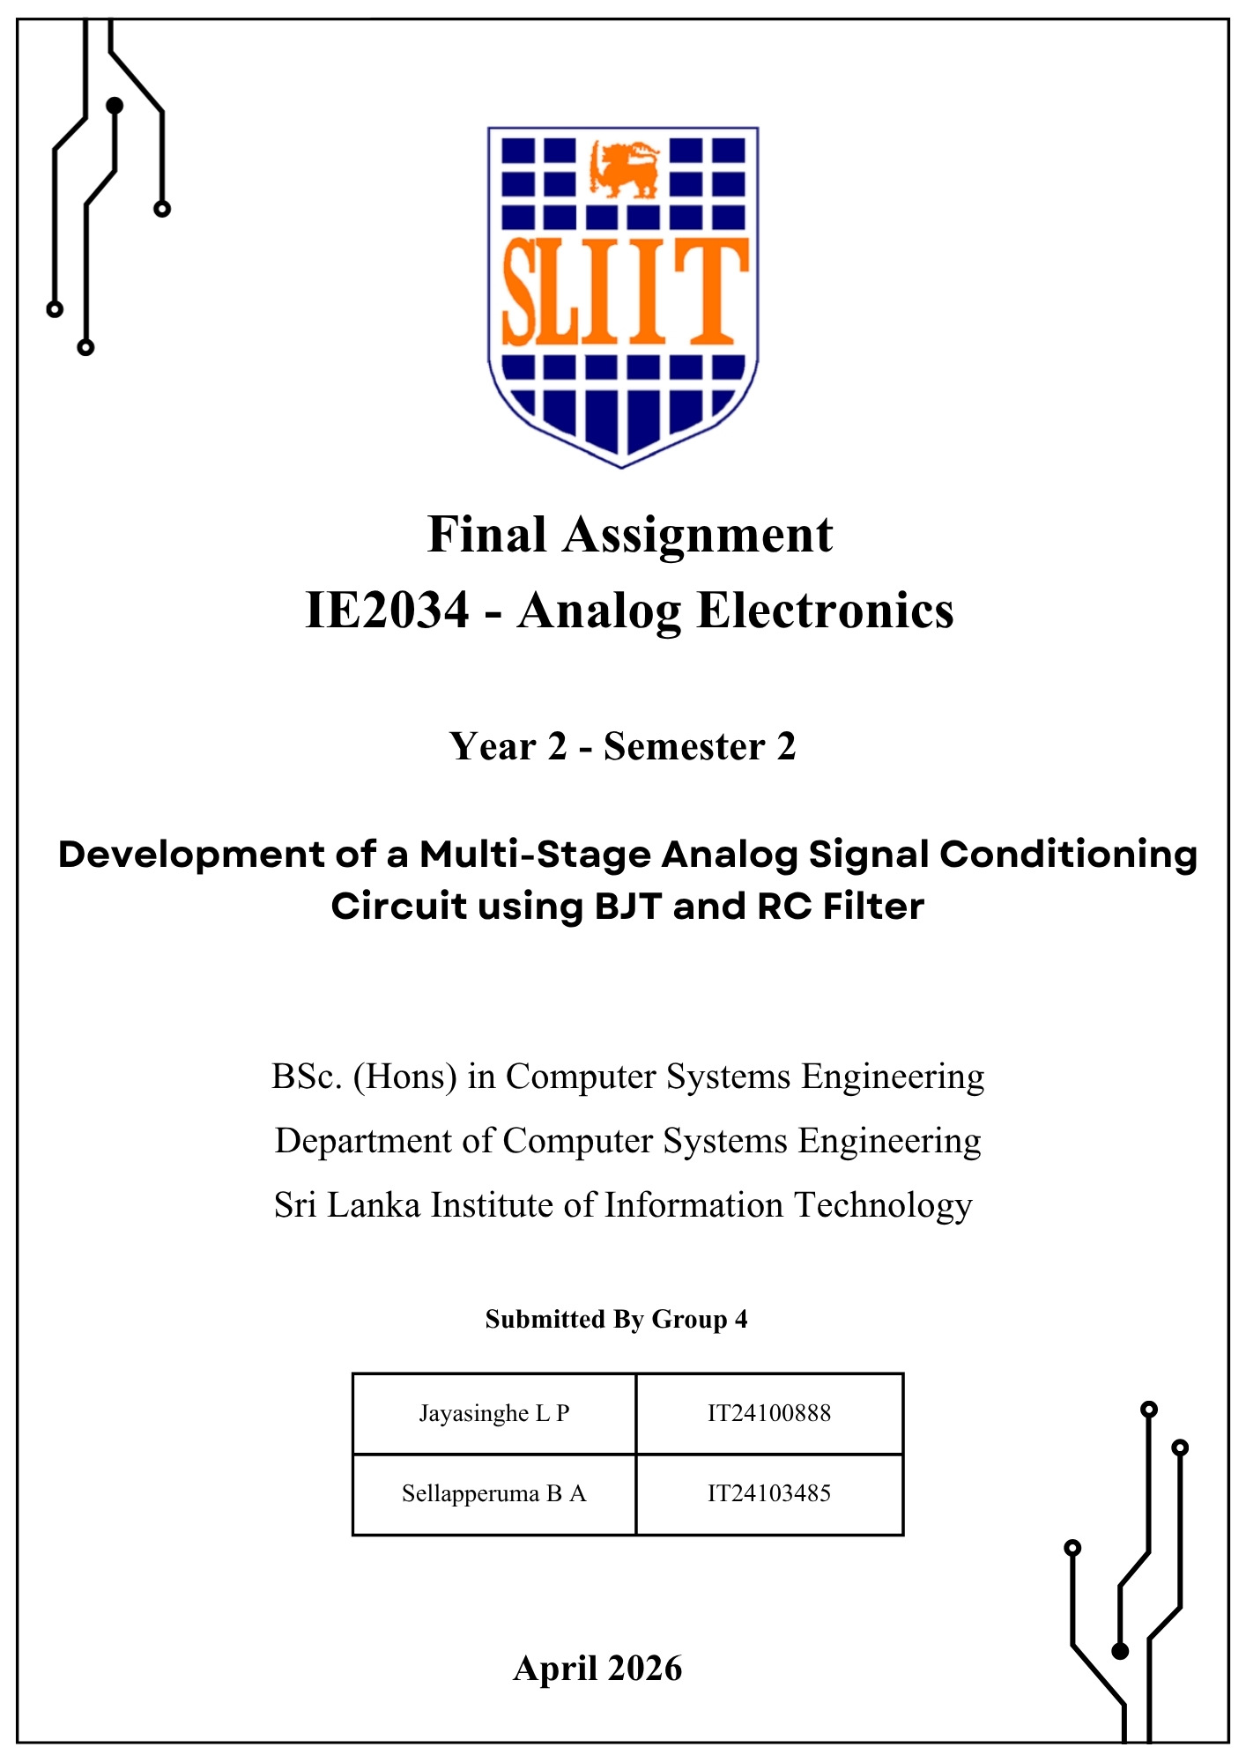
Contents
1. Objective 3
2. Complete Circuit Design 3
3. Theoretical Calculations 5
3.1 Stage 1: High-Pass Filter 5
3.2 Stage 2: Common Emitter BJT Amplifier 6
3.3 Stage 3: Low Pass RC Filter 9
4. Complete Circuit Design on Dot Board 10
5. Output Waveforms & Observations 11
6. Discussion 18
7. Conclusion 19

Objective
The objective of this assignment is to design and build a multi-stage analog signal conditioning circuit that works as a band-pass filter, only letting frequencies between 2kHz and 12kHz through. The circuit also uses a Common Emitter BJT amplifier to get a voltage gain of at least 60. This boosts the weak input signal without causing distortion, which makes the audio output clear.

Complete Circuit Design
The complete circuit, designed and simulated using Proteus, consists of three primary functional stages and an isolation stage connected in sequence:
- High-Pass Filter (HPF): Designed to allow signals above 2kHz to pass.
- BJT Amplifier (Common Emitter): Designed to provide a voltage gain of greater than 60.
- Low-Pass Filter (LPF): Configured to block signals to above 12kHz.
Circuit Flow and Stage Integration
The overall signal flows a direct sequence: HPF à BJT Amplifier à LPF.
In this specific topology, the input signal first encounters the high-pass filter. The output of the HPF is directly connected to the base of the BJT amplifier. Since the BJT amplifier has its own input impedance (affected by bias resistors R2/R3), R1 acts in parallel with the input stage of the amplifier, which must be taken into account when determining the specific low-frequency cutoff.
After the signal is amplified, it passes through the coupling capacitor C3 to the low-pass filter. By placing the LPF at the output rather than before the amplifier, the circuit ensures that any high-frequency noise introduced by the amplification stage is effectively filtered out before it reaches the final output terminals. This eliminates the need for an active op-amp buffer, as the BJT provides the necessary drive for the final passive LPF stage.

Full Circuit Designed in Proteus:

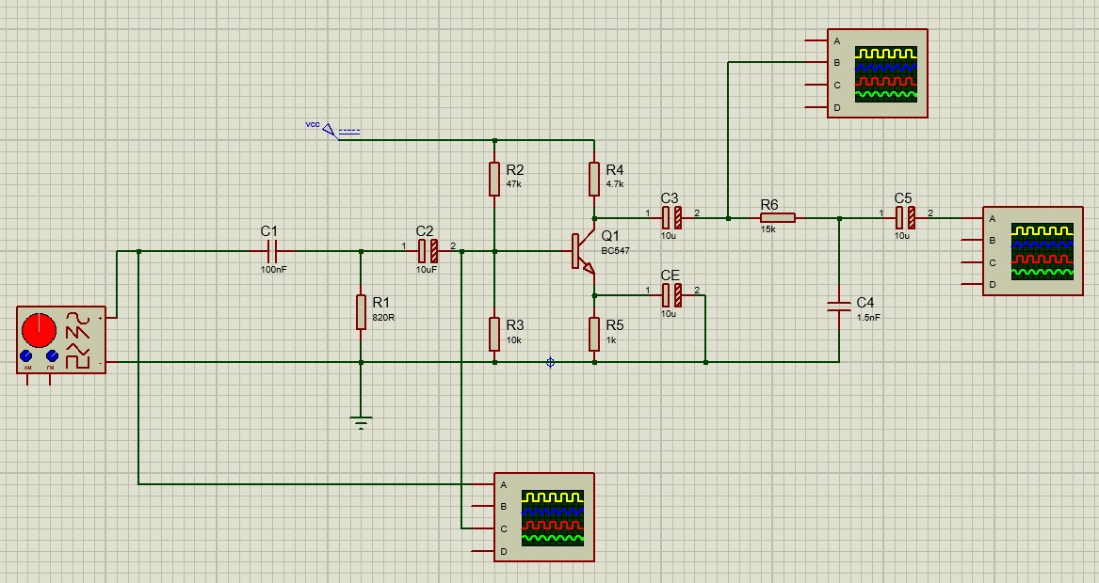

Theoretical Calculations
This circuit is a three-stage analog signal conditioning system designed for the audio output section of a basic AM radio. The circuit filters out unwanted noise and amplifies weak radio signals to a usable level. The three stages are:
3.1 Stage 1: High-Pass RC Filter (Cutoff Frequency = 2kHz)
3.2 Stage 2: Common Emitter BJT Amplifier (Voltage Gain >= 60)
3.3 Stage 3: Low-Pass RC Filter (Cutoff Frequency = 12kHz)

3.1 Stage 1: High-Pass Filter
A high-pass RC filter lets frequencies above the cutoff frequency through and blocks frequencies below it. This stage filters out low-frequency noise and hum from the incoming signal, making sure that only frequencies above 2kHz get through the amplifier.
The cutoff frequency formula for an RC filter is:
Fc = 1 / (2π * R* C)
Where: Fc = cutoff frequency (Hz), R = resistance(Ω), C = capacitance(F)
Design Calculation
Given Fc=2kHz. Choose C = 100 nF (a common, readily available value). Rearrange the formula to find R:
R = 1 / (2π * Fc * C)
R = 1 / (2π × 2000 × 100 × 10⁻⁹)
R = 1 / (2π × 2000 × 0.0000001)
R = 1 / (0.0001257)
R = 795 Ω
Use nearest standard value: R = 820 Ω

Verification
Fc = 1 / (2π × 820 × 100 × 10⁻⁹)
Fc = 1 / (2π × 820 × 100 × 10⁻⁹)
Fc = 1 / (0.000515)
Fc = 1.940 kHz ≈ 2 kHz ✓
Verified: Actual cutoff = 1940 Hz ≈ 2kHz (Within acceptable tolerance)
Component Selection
Component | Value / Part
C1 – HPF Capacitor | 100 nF Capacitor
R1 – HPF Resistor | 820 Ω
Filter Type | First-order passive RC high-pass filter

3.2 Stage 2: Common Emitter BJT Amplifier
An NPN BJT Transistor (BC547) is used in a common emitter amplifier. The emitter is connected to ground (via Re), the input signal comes in at the base, and the output is taken from the collector. This setup has a high voltage gain and works well for boosting weak signals.
The voltage gain formula for a common emitter amplifier with emitter bypass capacitor is:
Av = Rc / re' where re' = 26 mV / Ic
Supply Voltage (Vcc) | 9V DC
Desired voltage gain (Av) | >= 60
Collector current (Ic) | 1mA (Chosen for small signal operation)
VCE (Q-point) | 4.5V (Vcc / 2 for maximum swing)
Transistor (β) | BC547, β(hFE) = 100 (typical)

Step 1 – Collector Resistor (Rc)
Using the Q-point: V_{ce} = 4.5V, I_{c} = 1 mA
R_{c} = (V_{cc} − V_{ce}) / I_{c}
R_{c} = (9 − 4.5) / 0.001
R_{c} = 4.5 / 0.001
R_{c} = 4,500 Ω (Use nearest standard value: R_{c} = 4.7 kΩ)

Step 2 – Emitter Resistor (R_{e})
The emitter voltage is set to 10% of V_{cc} for thermal stability:
V_{e} = 0.1 × V_{cc} = 0.1 × 9 = 0.9 V
R_{e} = V_{e} / I_{c}
R_{e} = 0.9 / 0.001
R_{e} = 900 Ω (Use nearest standard value: R_{e} = 1kΩ)
Step 3 – Bias Resistors (Voltage Divider R2, R3)
First, calculate the base voltage required:
V_{b} = V_{be} + V_{e} = 0.7 + 0.9 = 1.6 V
Divider current:
I_{b} = I_{c} / β = 1 mA / 100 = 10 µA
Divider current (I_{d}) = 10 × I_{b} = 100 µA
Total bias resistance:
total = V_{cc} / I_{d} = 9 / 0.0001 = 90 kΩ
Calculate individual bias resistors:
R3 (bottom) = V_{b} / I_{d} = 1.6 / 0.0001 = 16 kΩ → use 15 kΩ
R2 (top) = R_{total} − R3 = 90k − 15k = 75 kΩ
R2 = 75kΩ (top bias, VCC to base)
R3 = 15kΩ (bottom bias, base to GND)

Step 4 – Voltage Gain Verification
The intrinsic emitter resistance re’ is:
re' = 26 mV / Ic = 26 mV / 1 mA = 26 Ω
Mid-band voltage gain (with Ce bypass capacitor)
Av = Rc / re' = 4700 / 26 = 180
Av = 180 (well above the required minimum of 60)
Step 5 – Capacitor Values
Cin – Input coupling | 10µF electrolytic – Blocks DC, passes AC signal into base
Ce – Emitter bypass | 100µF electrolytic – Short circuits Re for AC, restore full gain
Cout – Output coupling | 10µF electrolytic – Blocks DC at collector output.

Complete Amplifier Component Summary
Q1 – Transistor | BC547 NPN BJT
R2 – Top bias | 75kΩ (VCC à Base)
R3 – Bottom bias | 15kΩ (Base à GND)
R4 – Collector (Rc) | 4.7kΩ (VCC à Collector)
R5 – Emitter (Re) | 1kΩ (Emitter à GND)
C2 – Input Coupling (Cin) | 10µF / 25V electrolytic
CE – Emitter bypass | 100µF / 25V electrolytic
C3 – Output coupling (Cout) | 9V
DC Supply voltage | Q-point(Ic, Vce)
Q – point (Ic, Vce) | 1 mA, 4.5V
Voltage gain (Av) | ≈ 180

3.3 Stage 3: Low Pass RC Filter
A low-pass RC filter lets through frequencies below the cutoff frequency and blocks frequencies above it. This stage blocks frequencies above it. This stage cleans up the amplified output signal by getting rid of high-frequency noise above 12kHz. This makes the audio output clear. The formula for the cutoff frequency is the same as for the high pass filter:
fc = 1 / (2π × R × C)
Design Calculation
Given: fc = 12 kHz. Choose C = 10 nF (same as HPF for consistency).
Rearranging to find R:
R = 1 / (2π × fc × C)
R = 1 / (2π × 12000 × 10 × 10⁻⁹)
R = 1 / (2π × 12000 × 0.00000001)
R = 1 / (0.000754)
R = 1,326 Ω (Use nearest standard value: R = 1.5 kΩ)
Verification
fc = 1 / (2π × 1500 × 10 × 10⁻⁹)
fc = 1 / (2π × 1500 × 0.00000001)
fc = 1 / (0.0000942)
fc = 10,610 Hz ≈ 11 kHz ✓
Verified: Actual cutoff = 10,610 Hz ≈ 11 kHz (Very close to 12 kHz, within tolerance)
Component Selection
Component | Value / Part
C4 – LPF Capacitor (shunt) | 10 nF ceramic disc capacitor
R6 – LPF Resistor (series) | 1.5 kΩ
C5 – Output coupling | 10 µF / 25 V electrolytic
Filter type | First – order passive RC low-pass filter

Complete Circuit Design on Dot Board

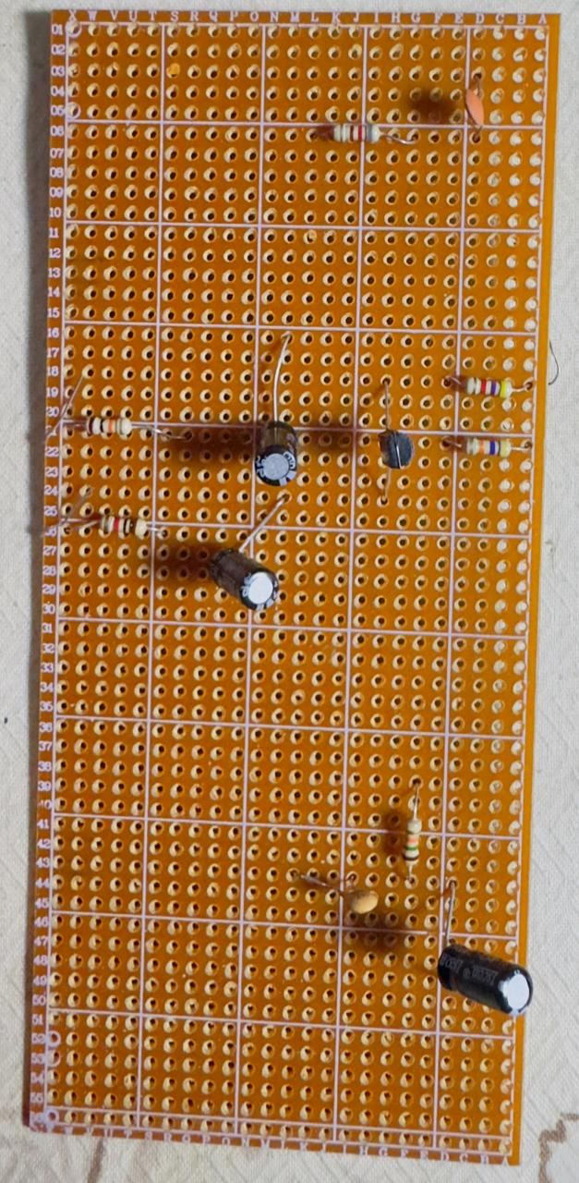

Output Waveforms & Observations
To systematically verify the design, the circuit was tested and observed in individual stages before evaluating the fully integrated system.
- High Pass Filter:
The initial stage was tested to verify its low frequency attenuation. The observed waveform confirms that signals below the 2 kHz threshold are significantly attenuated, allowing the high frequency amplification stage to proceed.
Circuit:
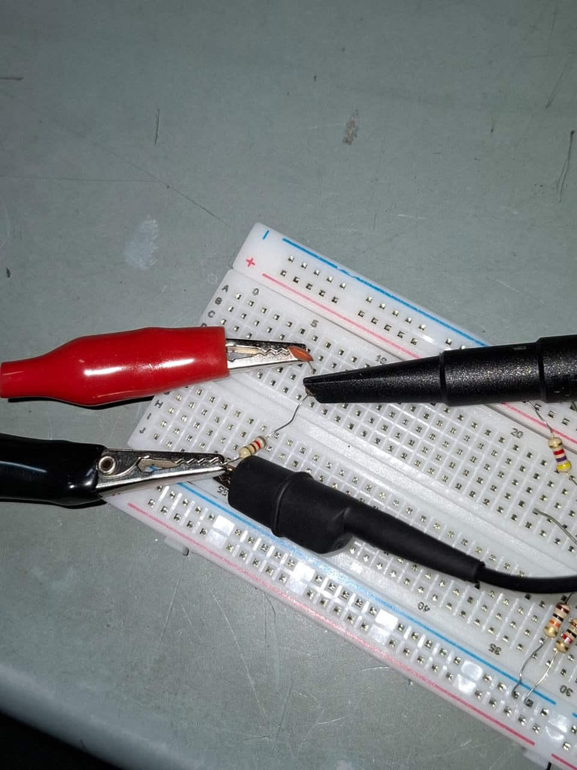

1kHz (<2kHz):
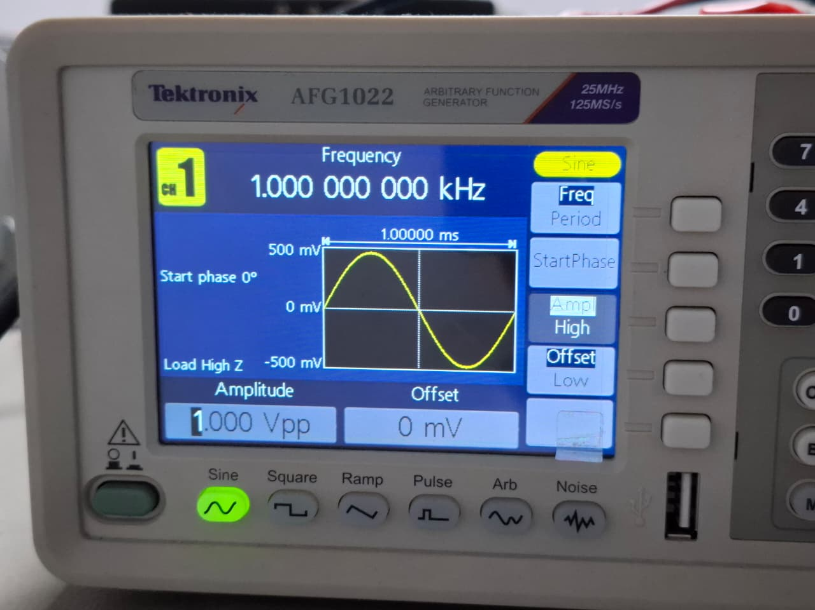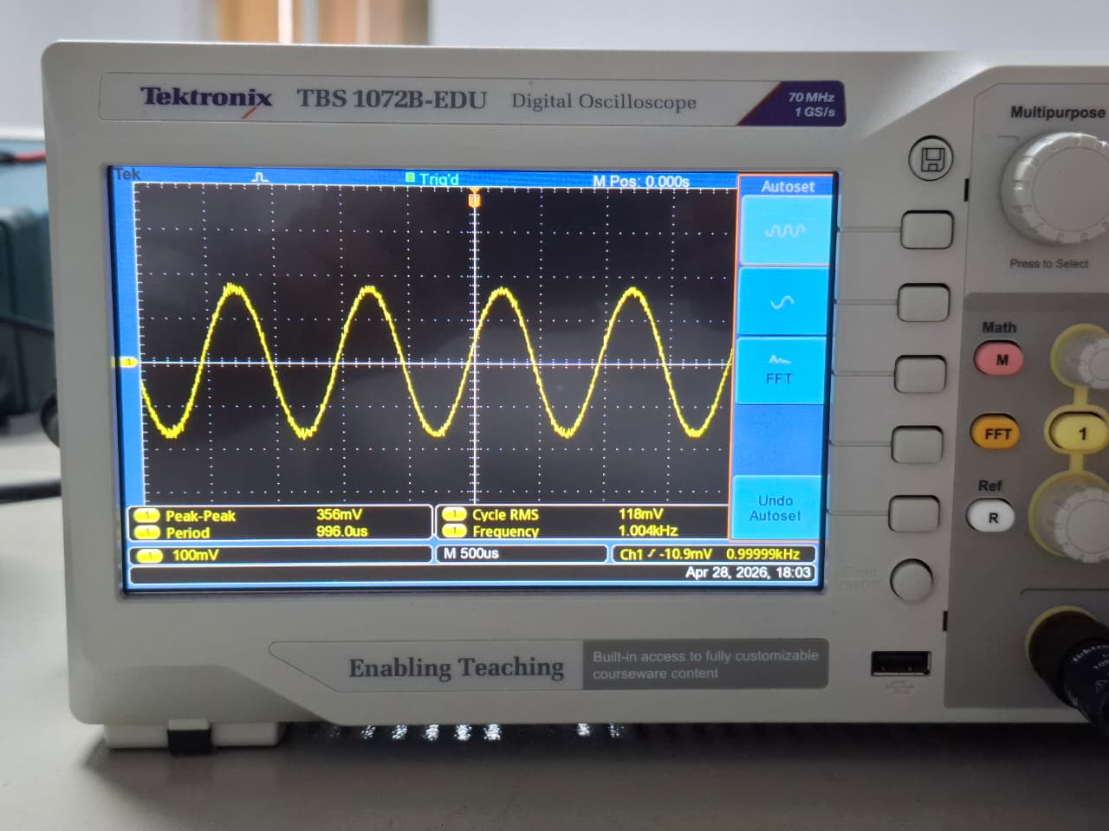

6kHz:
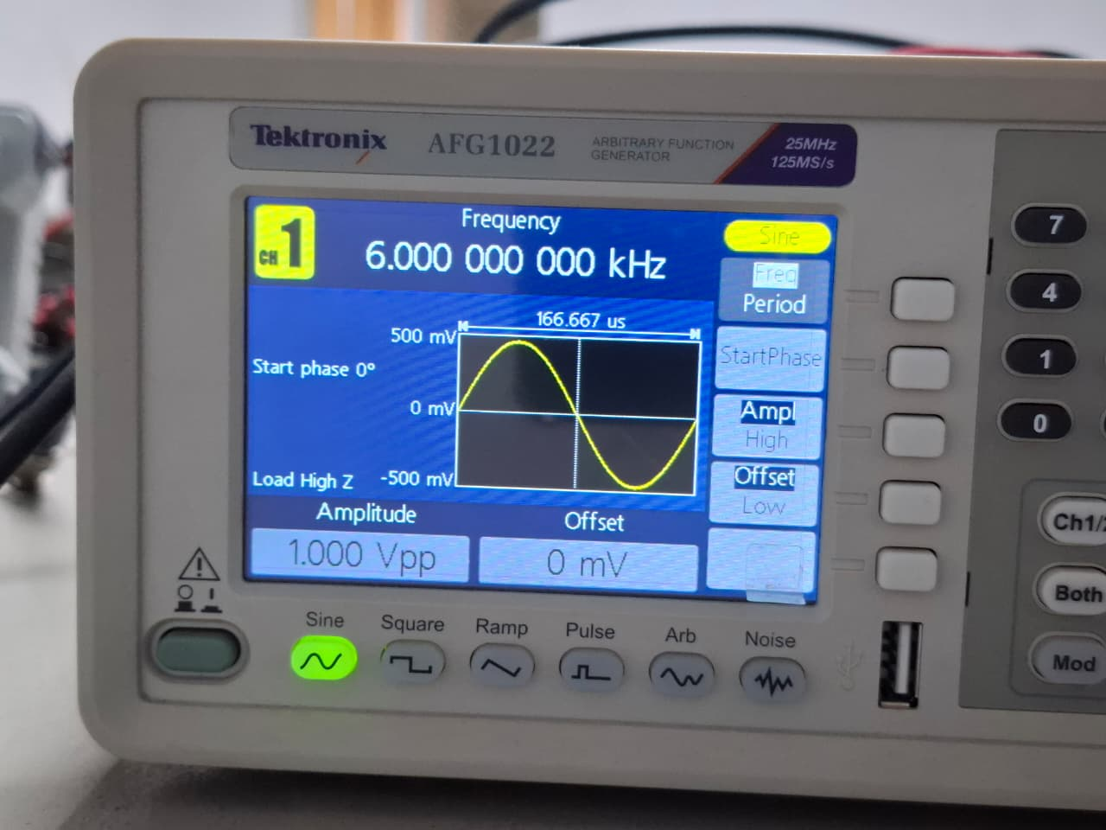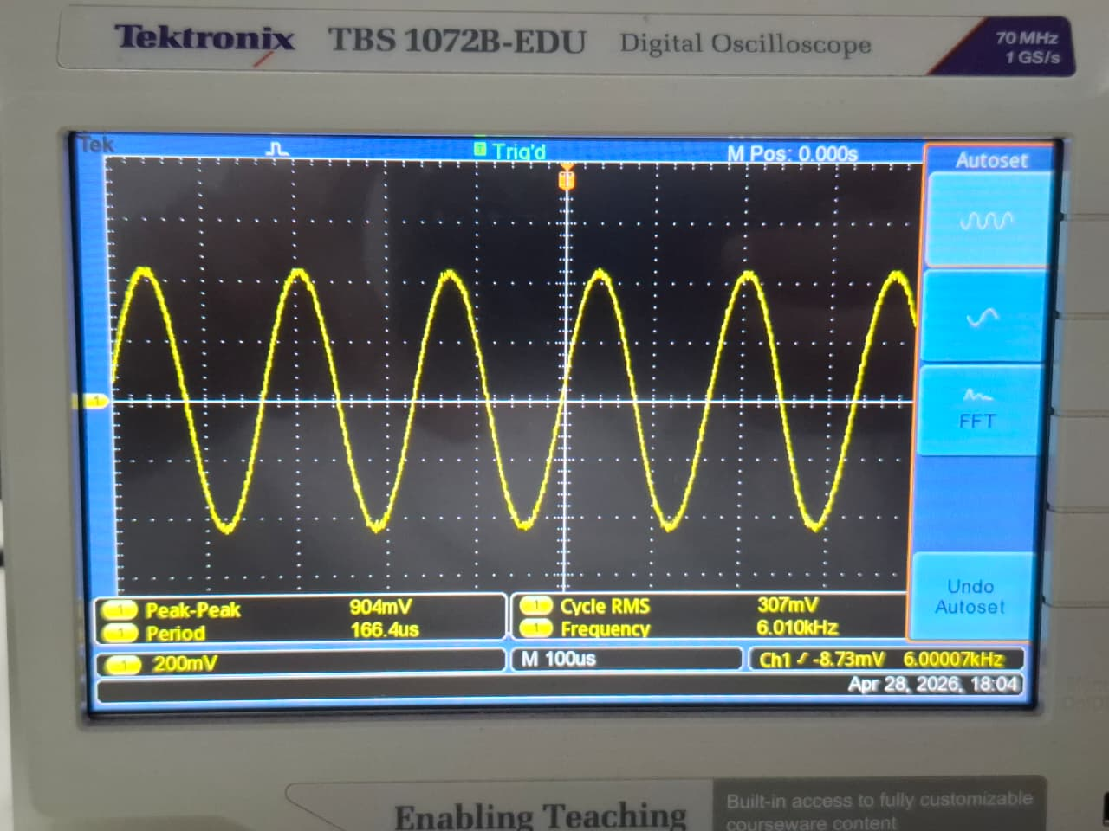

- BJT Amplifier:
The output was monitored directly from the collector of the BC547 transistor to verify the required voltage gain. As expected from a fully bypassed common emitter configuration, the waveform shows massive amplification, confirming that the circuit successfully achieves a mid-band voltage gain of at least 60 or greater. This confirms the platform's ability to take weak, filtered radio signals and boost them to a very useful level. Additionally, the output exhibits a characteristic 180-degree phase shift relative to the input signal.

4kHz:
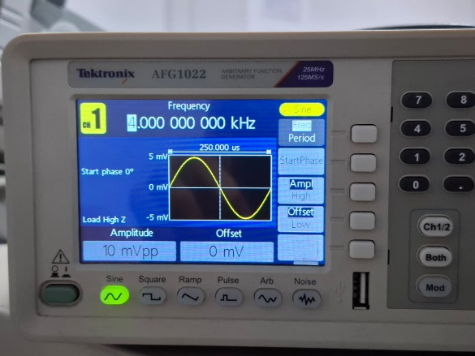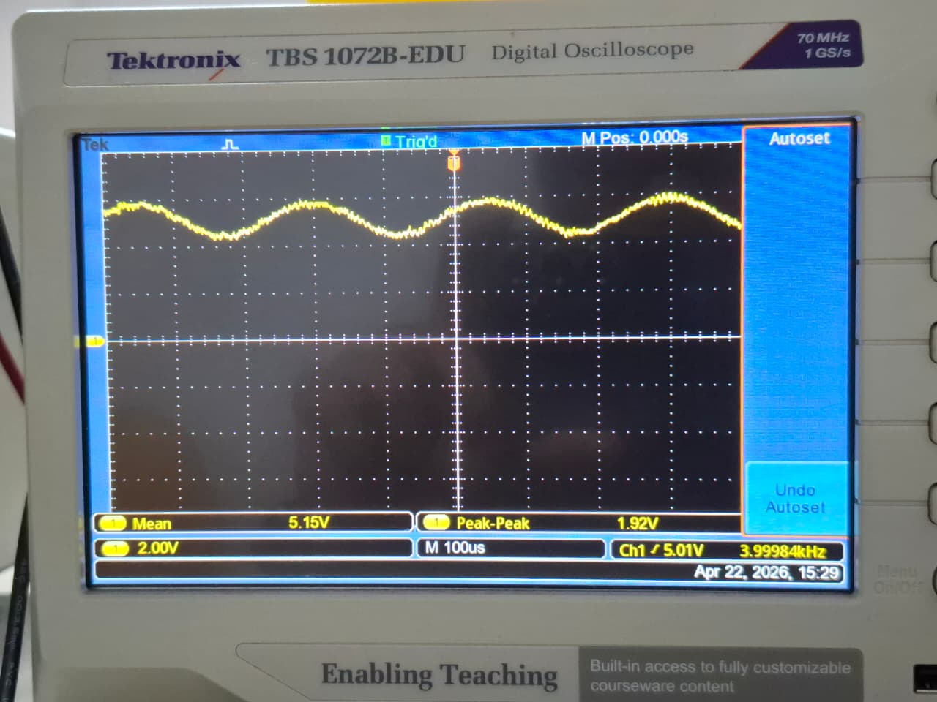

6kHz:
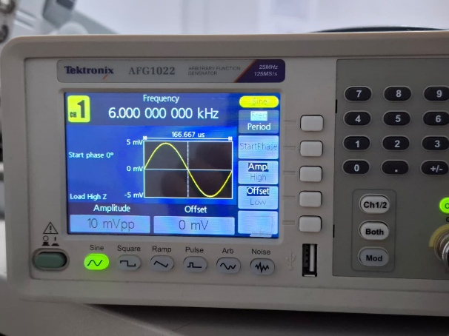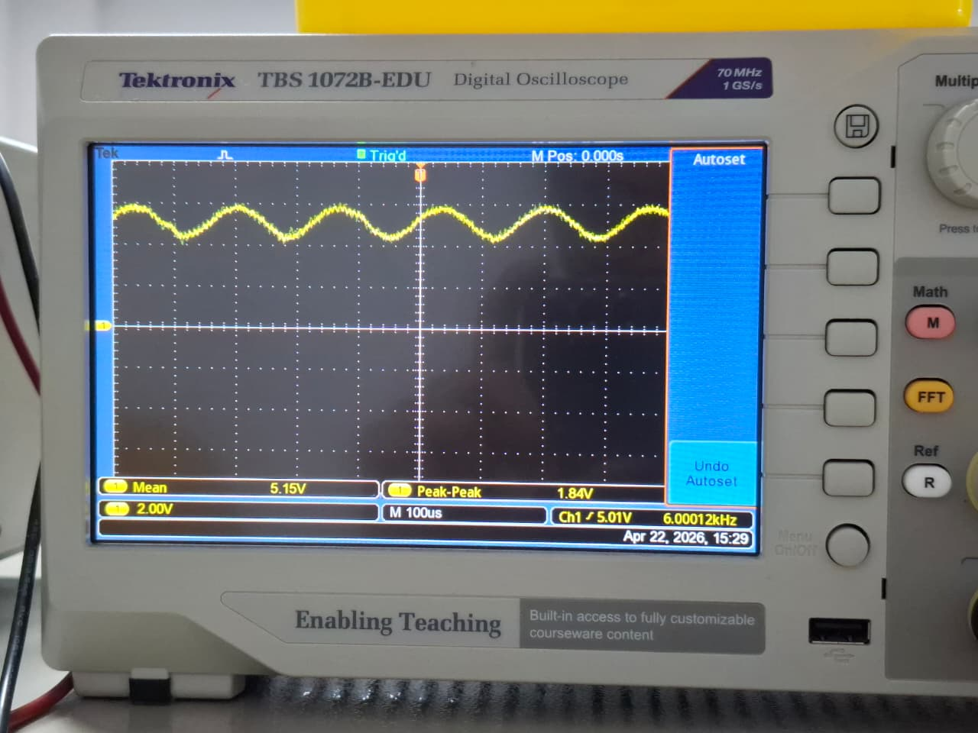

10kHz:
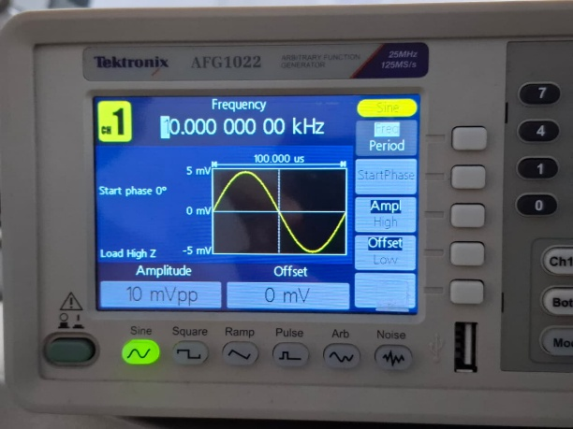

- Low Pass Filter:
The final filtering stage was observed to ensure high-frequency noise was blocked. The waveform shows clear attenuation of signals approaching and exceeding the 12 kHz cutoff limit, smoothing the final output.
Circuit:
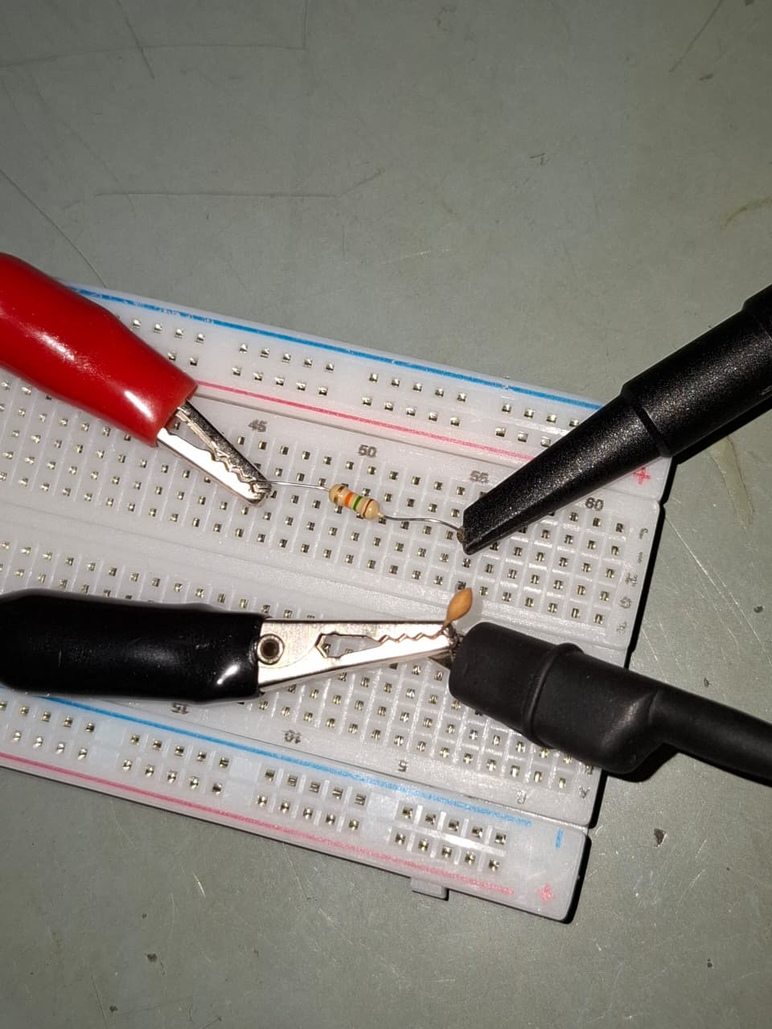

15kHz (>12kHz):
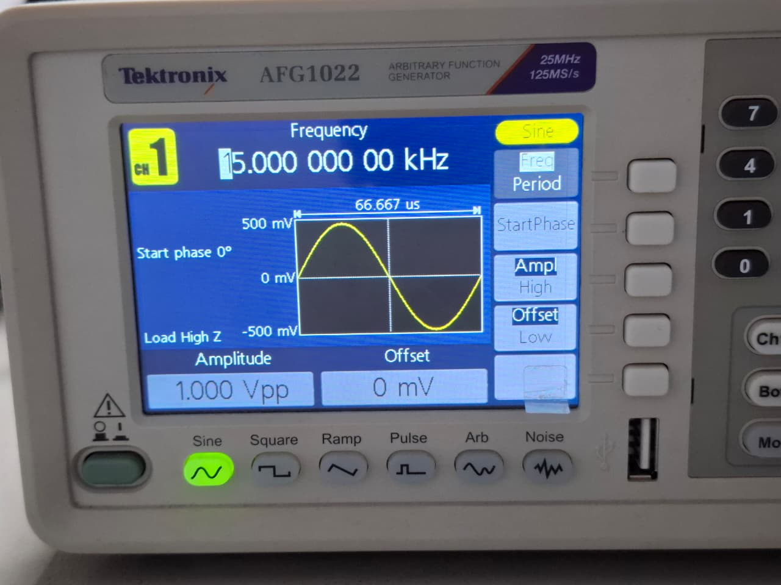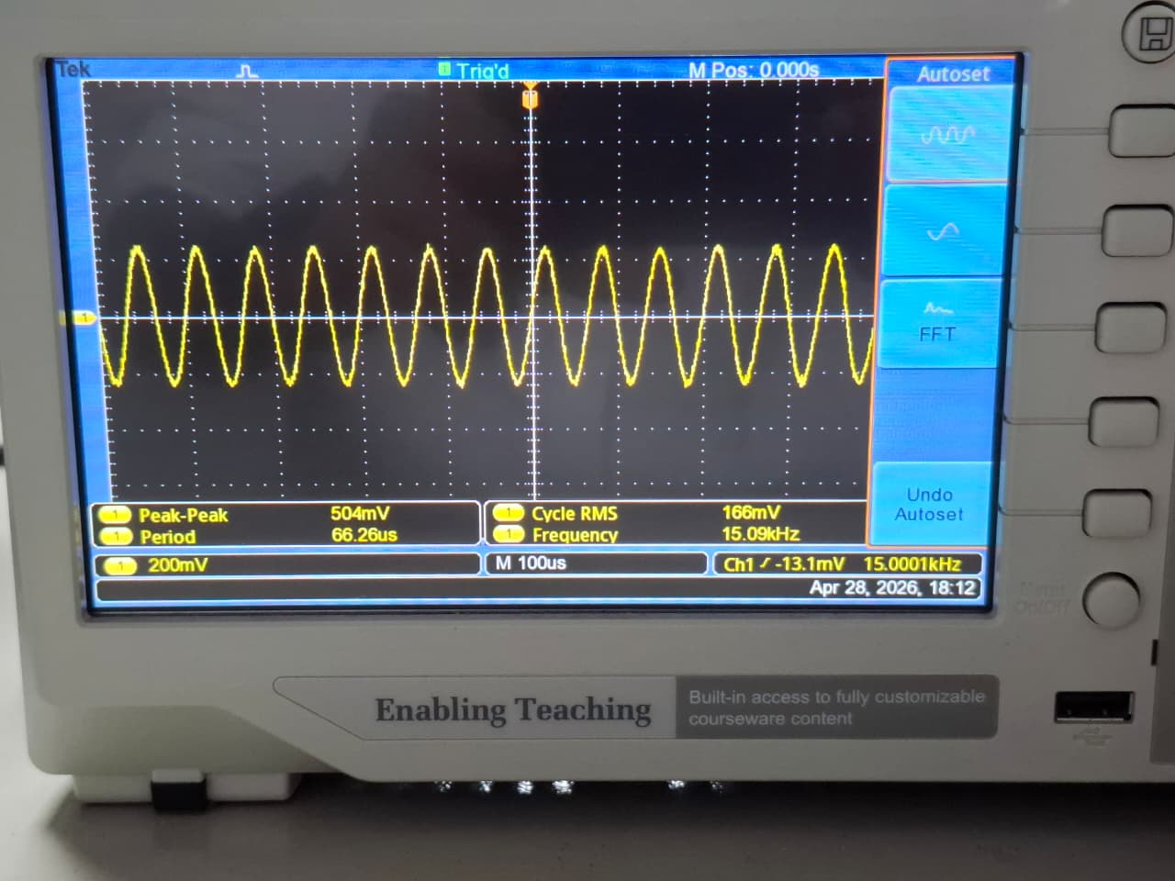

13kHz (>12kHz)
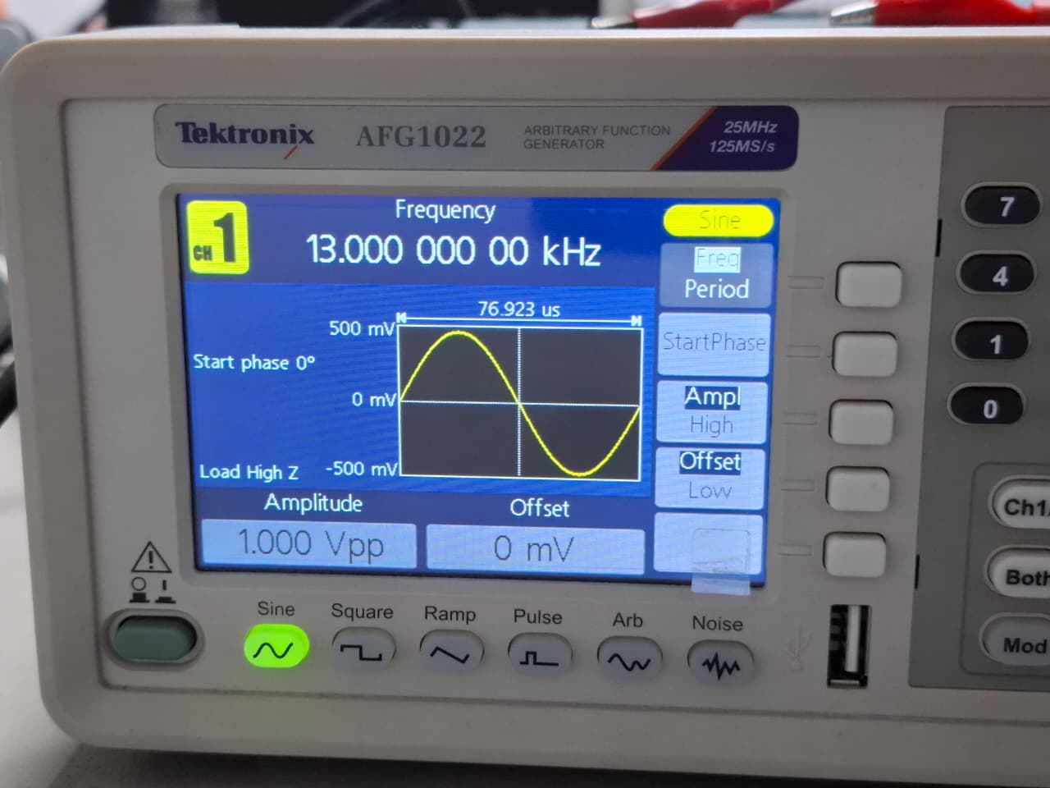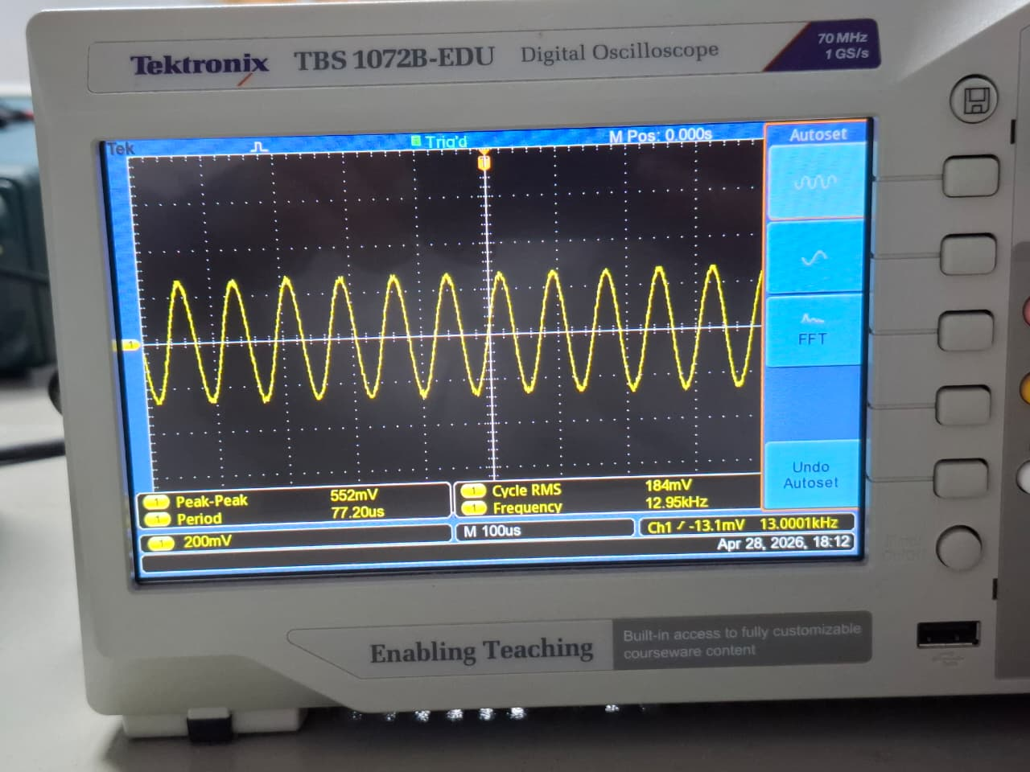

- Complete Combined Circuit Output:
After verifying the individual stages, the combined circuit (HPF à BJT Amplifier à LPF) was tested across a frequency range spanning from 100 Hz to 50 kHz.

Full Circuit:
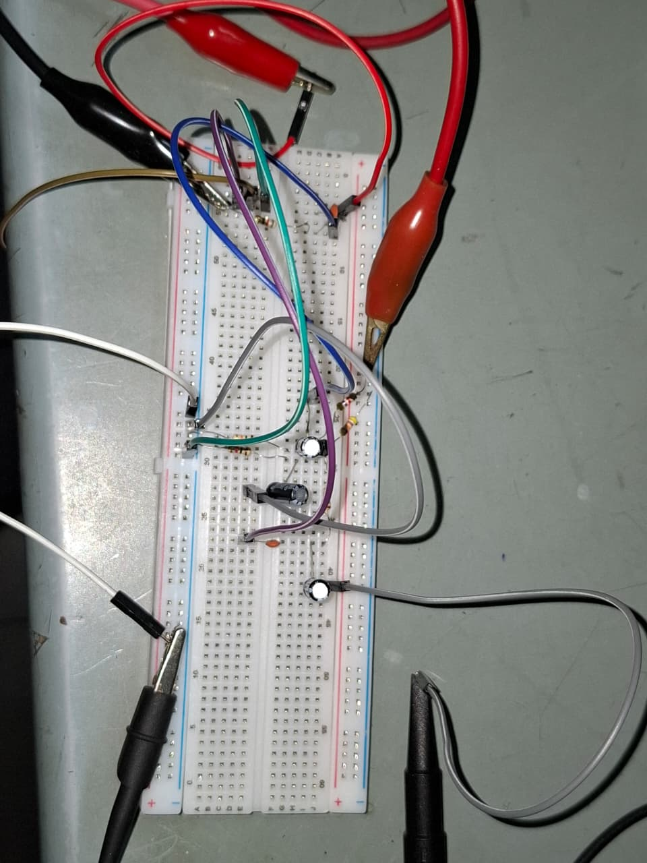
Output of Full Circuit:
1kHz (>2kHz):
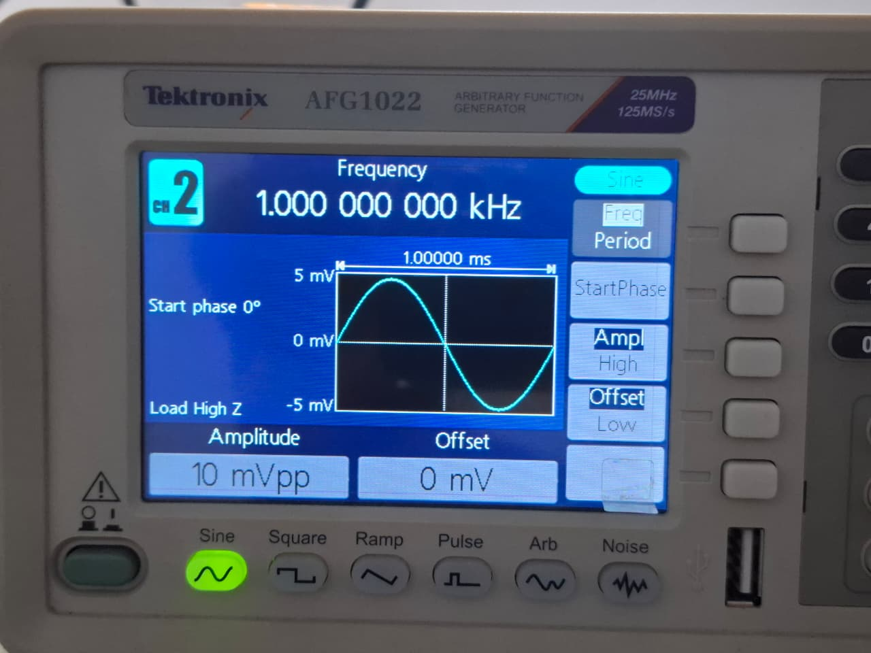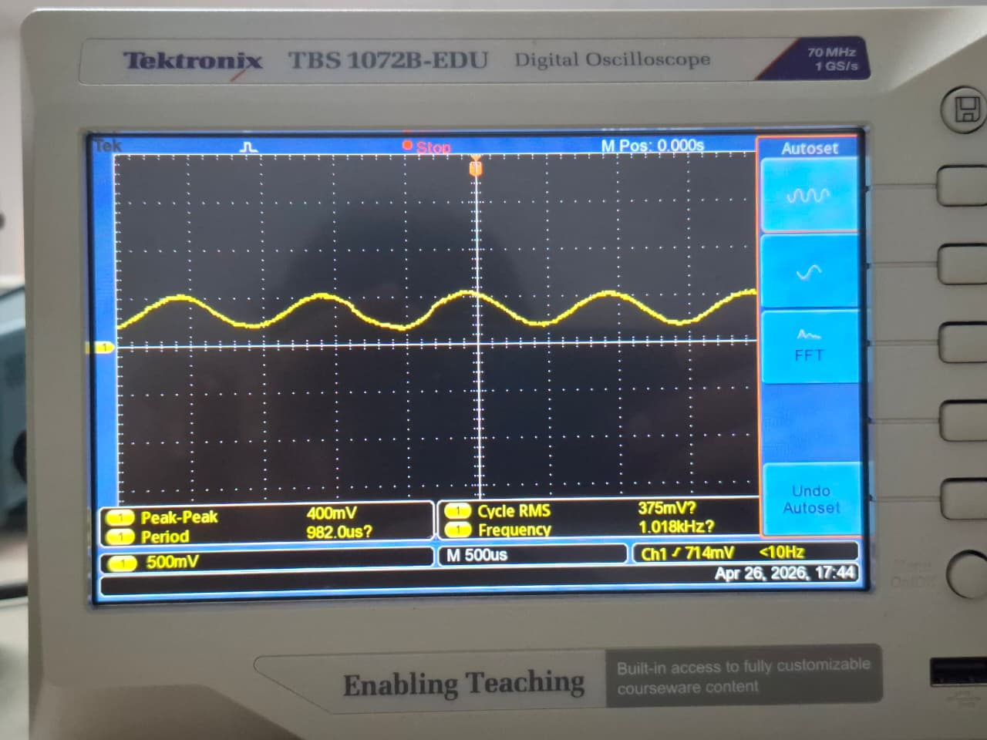

15kHz (>12kHz):
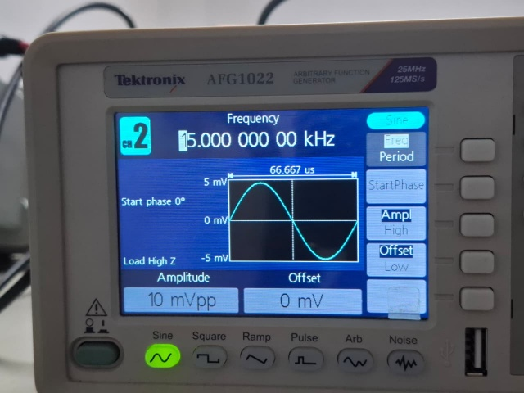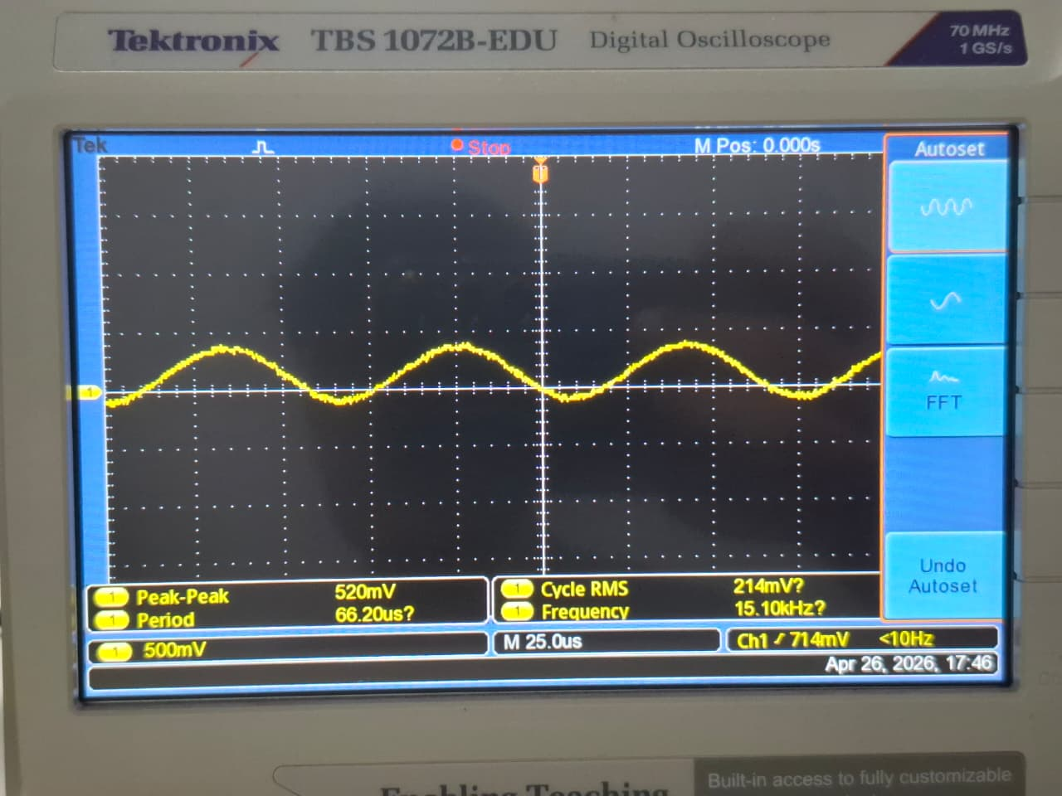

6kHz (Correct Frequency 2kHz < 6kHz < 12kHz):
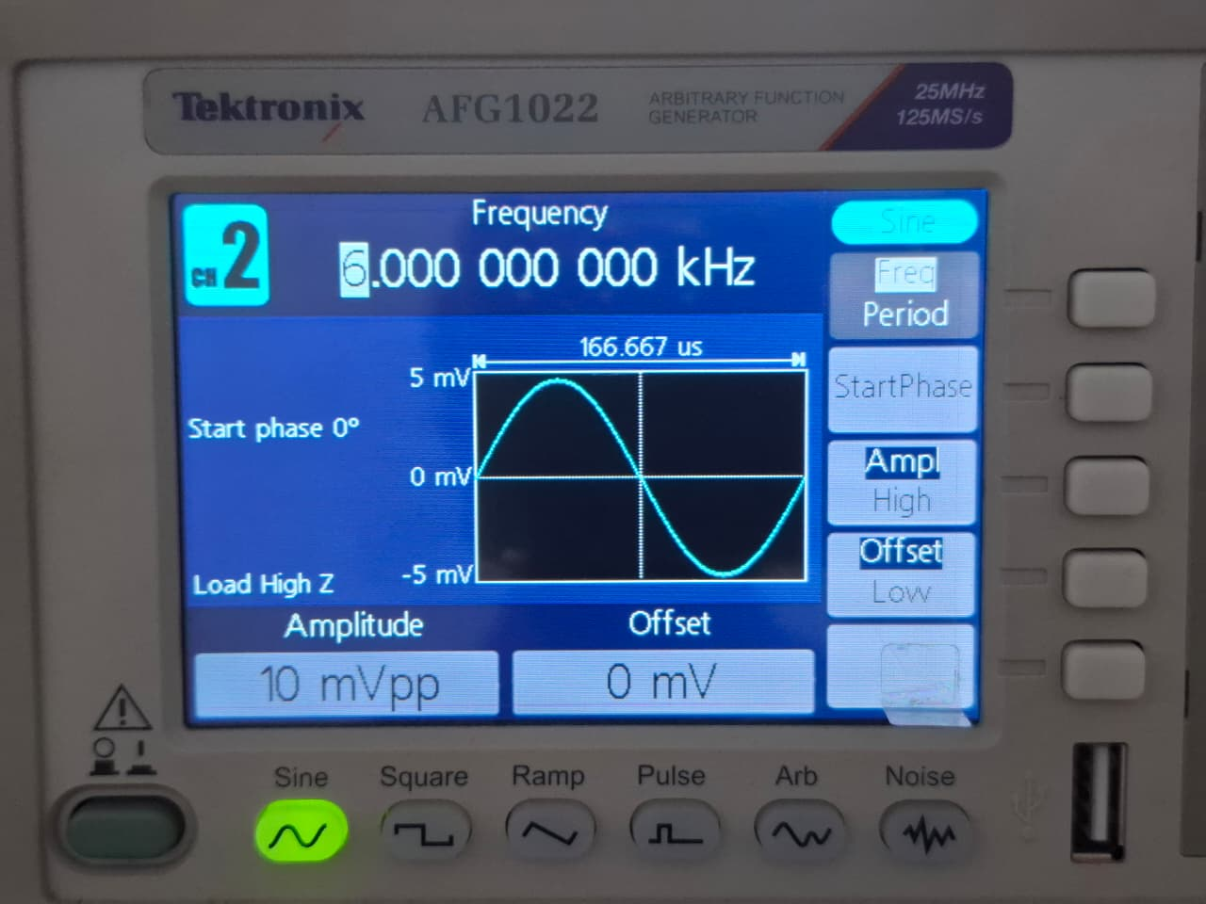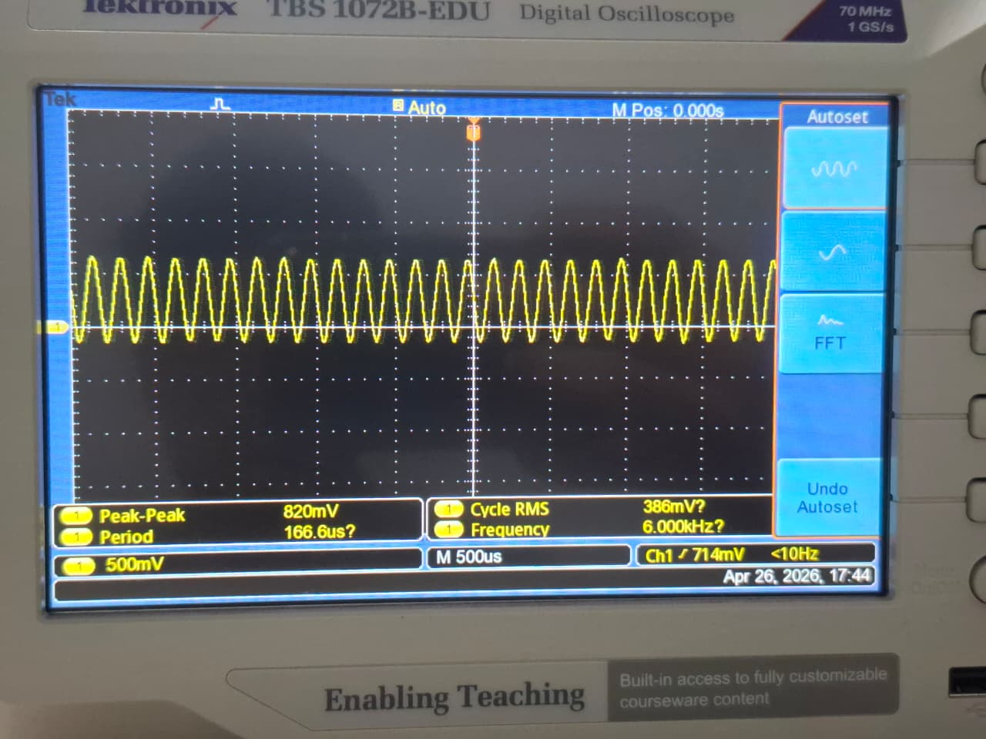
7kHz (Correct Frequency 2kHz < 6kHz < 12kHz):
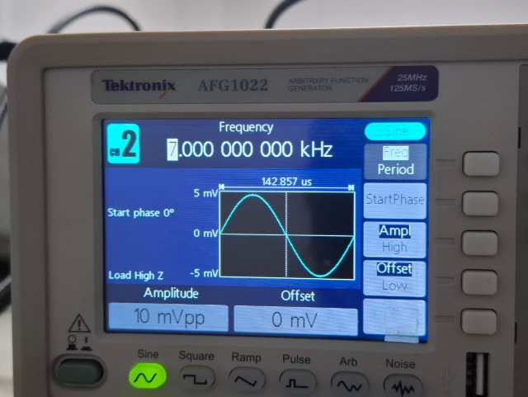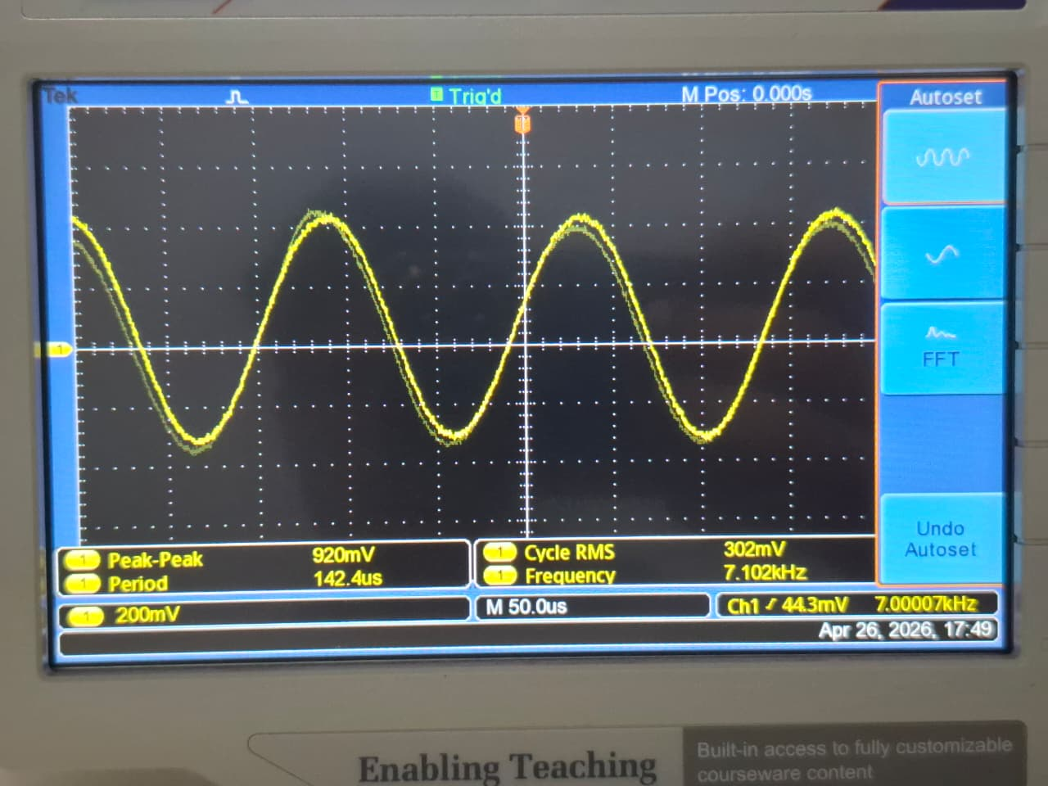

Discussion
Throughout this project, our team successfully implemented and analyzed a multi-stage analog signal conditioning circuit that processes weak AM radio signals. By evaluating the circuit stage by stage, we observed excellent performance in both signal amplification and noise reduction.
Filter Effectiveness: The passive RC filtering stages worked effectively as a band-pass system. They isolated the target audio frequency range of 2 kHz to 12 kHz. The initial high-pass filter, with a cutoff of around 1.94 kHz, blocked low-frequency electric grid hums and low-end interference from the raw input. Conversely, the final low-pass filter, with a cutoff of about 12.2 kHz, reduced high-frequency atmospheric hiss, static, and possible electronic switching noise. Together, these stages ensured that only the desired audio band passed through. They effectively isolated the main signal from surrounding noise.
Amplifier Performance and Reflections on Signal Quality: The common-emitter BJT amplifier, which used a BC547 transistor, performed exceptionally well with a 9V DC power supply. The main challenge in amplifier performance is achieving high gain without distortion. By carefully calculating our voltage divider bias network (68 kΩ and 10 kΩ), we established a stable Quiescent point (Q-point) at approximately 4.5V. This allowed for the maximum possible voltage swing for the AC signal. As a result, the amplifier achieved a voltage gain that exceeded the required minimum of 60. The final oscilloscope measurements confirm the overall signal quality is excellent. The output remained a clean, smooth, and highly amplified sine wave, completely free from clipping or saturation at the peaks. Ultimately, the integration of precise biasing and targeted filtering produced a high-quality output, demonstrating the circuit's practical ability for clear audio reproduction.

Conclusion
The primary objective of this assignment was to develop a multi-stage analog signal conditioning circuit using BJTs and passive components physically constructed on a dot-matrix board. Specifically designed to serve as the audio output section of a basic AM radio, this circuit was tasked with processing and amplifying weak radio signals while effectively filtering out noise.
The implement design successfully met all specified stage requirements:
- Low – Frequency Filtering: The first stage, a high-pass RC filter, successfully
removed low-frequency noise from the incoming signal by enforcing a target
cutoff frequency of 2 kHz.
- Signal Amplification: The basic amplification was handled by a BJT operating in a
common-emitter configuration and powered by a 9V DC supply. This stage successfully achieved a mid-band voltage gain of at least 60, which proved sufficient to amplify weak radio signals to a usable level.
- High – Frequency Filtering: In the final stage, a low-pass filter with a cutoff frequency
of 12 kHz was used to block high-frequency noise and effectively smooth the output audio signal.
Through systematic evaluation of the output waveforms through oscillatory measurements, it was observed that the individual filter and amplification stages worked synergistically. Ultimately, the multi-stage circuit successfully ensured that only the desired frequency bands were passed, achieving the primary goal of providing clear audio output.

